Why I think the AIMS coral cover data is useful.
It is a well worthwhile exercise to question how valid and useful is the Australian Institute of Marine Science (AIMS) data of coral cover. It has been pointed out that the AIMS measurements rely on a subjective judgement of the coral cover and that the transects are not representative of the coral on the whole reef. While accepting both these problems, my view is that the measurements are useful for gauging changes to the GBR over time.
How is the data collected?
AIMS uses the manta-tow method to survey hard coral. This involves towing a diver around the perimeter of a reef. The diver observes coral cover over a 100-200 meter distance and records the percentage estimate. This is a subjective estimate. The diver is trained to do this, Each reef is many kilometres/miles around its perimeter so there could be roughly 50 to 100 individual estimates for each reef.
The data for the GBR is broken into three regions; Northern, Central and Southern. These regions are broken into ‘sectors’ with 3, 5 and 3 sectors in the Northern, Central and Southern regions respectively. For each of the 11 sectors, there are roughly 5-10 individual coral reefs surveyed. Data is aggregated in an objective way (averaging and weighting) to give a coral cover statistic for each reef and further aggregated to give a statistic for each sector or region.
Of the 3000 reefs of the GBR, around 100 are surveyed each year. Divers are towed a distance of roughly 1000 km – which give a good idea of the enormous size of the task, and why a rapid assessment of the coral is important
Can a subjective measurement be useful?
Yes, and there are many examples in science where subjective measures are used – usually to allow very rapid and inexpensive collection of data similar to monitoring coral. For example, for collecting data of vegetation cover in pasture, a simple subjective measure is often used. Figure 1 shows examples of different plant cover percentage over the ground. It is relatively simple to train an observer to give a useful measure of plant cover. Different observers would need to be trained to minimise the uncertainty.
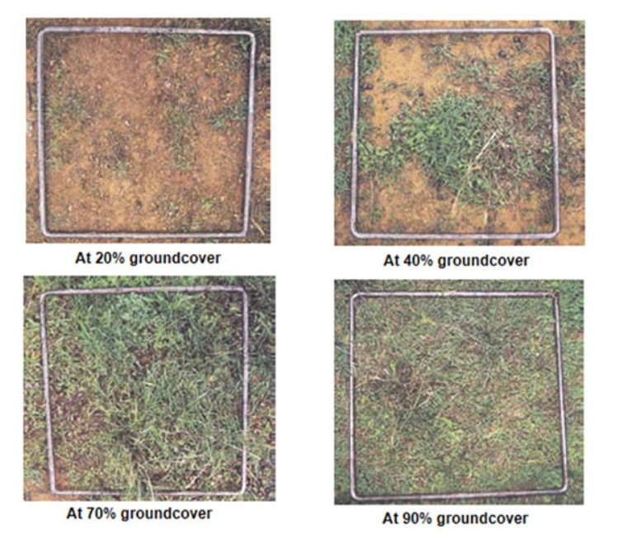
Figure 1: Estimation of ground cover in pasture. Different observers will not estimate exactly the same number, but with training the uncertainty margin can probably mean that two observers will agree within 10%.
There are many other areas where humans are well able to estimate measurements without any form of instrument. For example, the height of a human ranges from about 60 cm (2 feet) for a toddler child to about 215 cm (7 feet) for an American basketball player. Almost anybody can estimate the height of another person, to within 30 cm (1 foot) and most people can do much better than that. Skilled carpenters can look at a cabinet, kitchen or wall and estimate its dimensions with remarkable accuracy – better than 10 cm for lengths less than 2 m. Machinists who work on lathes can look at variations on a turned circular surface and estimate step variations to within a few thousandths of an inch. It is obviously better to do all of these things with a tape measure or micrometre as this drastically reduces uncertainty. But a subjective measure can give useful data provided the size of the uncertainty can be gauged and is not too large for the application at hand.
Humans use subjective assessment of the size and distance to objects in many day-to-day activities. Driving a car requires extremely good ability to judge the distance and speed of approaching cars; or judging if the size of a parking bay, or gap between two objects, is big enough for their car. Ball sports from football to snooker also require a remarkable ability to judge distances. Training and practice is the key to minimising uncertainty margins.
Subjective measures are also used in other fields such as teachers marking exam papers, essays and even answers to mathematics questions (when the answer deserves part marks). These subjective measures can then be “added” or aggregated in some objective form to produce a useful measure of the relative performance of students. Just like using an objective system to aggregate the subjective coral cover assessments.
The point has been made that technology now exists to use artificial intelligence (AI) methods to remove most of the subjectivity from the process of estimating coral cover. I agree that this is the way things should go as soon as possible and I understand that AIMS is working on this. But even with AI, the result one gets depends upon the input parameters for the AI model. I have had considerable experience with AI algorithms to detect weeds in pasture, and the way one sets up the parameters affects greatly the final results. There is a degree of subjectivity in the way the parameters are chosen. The most important thing, for the coral example, is to make sure that, whatever method is used, it is applied consistently. If there is a move to AI, the current method and new method must be used concurrently for a number of years so that there is confidence in the new method and the previous data is not wasted.
So, in conclusion, the subjective estimation method has weaknesses and could be largely avoided with modern technology, but this does not mean that the estimation method has no value. Part of the value of the coral cover data is that it goes back to 1986 and we cannot retrospectively apply the AI methods to the past. Also, surveys should be videoed as a matter of routine so that future AI technology can be retrospectively applied and others can check the data.
The problem of only measuring coral on reef perimeter
By only measuring coral cover on the perimeter of the individual reef, the data is not necessarily representative of the average for the entire individual reef. Many of the reef crests have much higher coral cover. Some of the reef flats have no coral due to air exposure at king low tides (as a result of sealevel fall over the last 5000 years). The centre of many reefs is dominated by sand where there is also no coral. However, if one is interested in changes of coral cover with time, this is not a problem provided it is safe to assume that the factors affecting coral cover (cyclones, crown-of-thorns starfish, bleaching, recruitment and growth) do not vary too much across the different parts of the reef. Cyclones, the major factor reducing coral cover affects virtually the entire reef with water depth less than 20 m. I am not aware of any evidence to suggest that recruitment of coral larvae, or the growth of juvenile corals is grossly different over different regions of the reef.
But even if there are some significant differences in the way coral cover changes with time between different regions of an individual coral reefs, having the data for the perimeter is far better than having no data at all. The reef perimeter is a huge amount of coral. Because AIMS has always measured the perimeter since 1986, we can have some confidence that they can detect changes - at least for the perimeter.

Data Coherence and Noise
Provided one is interested only in changes in coral cover with time, one way to gauge the usefulness of the data is to look at the “noise” – fluctuations over time. If the data routinely bounced around from small to high numbers and back, this would be a sign of very high inaccuracy. In addition, coral cannot suddenly go from 10% cover to 90% cover in one year – it does not grow that fast. Useful data should see gradual changes with time as coral grows and sometimes very rapid falls due to impacts from cyclones. Also, a cyclone is a big system and will always affect many neighbouring reefs. If the data does not show a major reduction in coral cover on all reefs affected by the cyclone, it would be a major red flag that there is a problem with the data inaccuracy and noise.
But the AIMS data is highly consistent in these regards. After a big cyclone, the data of many reefs collapse. The gradual recovery is apparent. The data is not hopelessly noisy which would be the case if the subjective measurements were completely useless.
For example, the data for the Cooktown section of the reef is shown in figure 2. There is considerable fluctuation in the data, but the large collapse in 2016 after a bleaching event (easily the worst bleaching of any region on record) and the subsequent recovery is very clear. If the data was too noisy, this fall and recovery would not have been clear. The monotonic recovery is also very evident - the coral was recovering at a very rapid rate, so even though the data has a large uncertainty margin the recovery can be distinguished. This is a good sign that the data is useful.
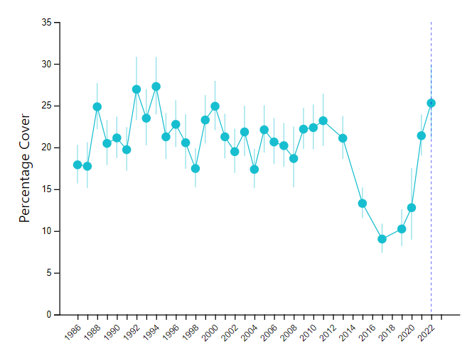
Figure 2: Coral cover for the Cooktown/Lizard section of the reef.
Also, the chances that the 5 years from 2017 to 2022 would have such a striking monotonic rise in value would be very small if the data was random noise caused by high observer error. It would be like throwing a dice five times and getting a perfect rising consecutive sequence such as 2, 3, 4, 5, 6. This is a 1 in 1296 chance. Such coherence in the data is strongly indicative that there is a genuine “signal” in the data that is not overwhelmed by the “noise” from the data collection.
Such monotonic, or almost monotonic, sequences abound in the data, at reef, sector, and regional scale. For example, the data in figure 3 below shows the results for the Capricorn Bunker region of the reef. Again, there is significant noise of 10%, but there is considerable coherence between different years without unreasonable rapid increases. The large mortality associated with Cyclone Hamish is clear in 2009/10 as is the very steady increase in coral cover since then. There is no possibility that such a steady increase could occur in a purely random data series.

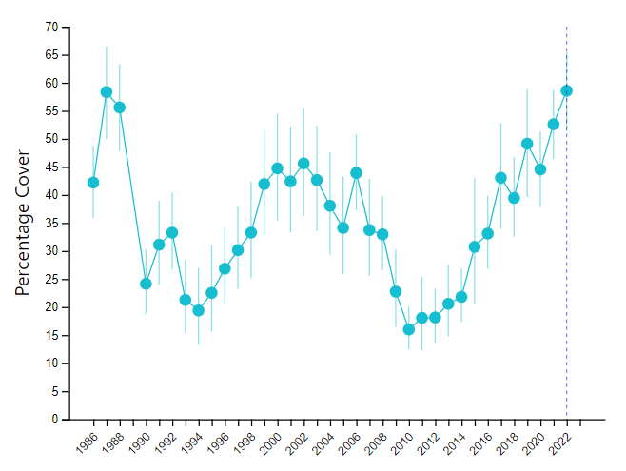
Figure 3: Coral Cover for Capricorn Bunkers.

A caveat
The fact that the data is based upon a subjective judgment of each 100-200 m section of the reefs surveyed means there is an obvious need for a high degree of quality assurance for the task. Unlike many other measurements of the reef (aerial bleaching and coral calcification data), in my view, AIMS has very useful QA systems for these surveys, at least in the last 25 years. However, an external audit of the surveys would be very valuable to maintain confidence in the data. It is possible that accusations could be made in the future that the divers might manipulate results in their subjective judgements to downgrade the coral result in the future. This has clearly not happened as AIMS is reporting record high coral cover. There is clearly a high degree of integrity of Mike Emslie and his team for the manta tow surveys. But a system of external audits would be very useful to maintain the integrity of the surveys in the future. For any audit to be effective, it will be essential that video be taken of the surveys. This is not a trivial task due to highly variable lighting and water turbidity, and would require extra man-power, but it would be worth doubling the funding for this coral cover work as it is such an important survey.
Summary
There is no doubt that the coral cover data has weaknesses – all data sets do. The data certainly has a large uncertainty margin which means that small changes cannot be resolved. But as a measure of large scale fluctuations in coral cover, I have no doubt that the data is very useful. .

See for example https://doi.org/10.1890/ES13-00300.1 or http://www.nrm.gov.au/publications/estimating-ground-cover-percentage

