Comment on uncertainty estimate of AIMS coral cover statistics
Introduction.
Up until 2016, AIMS published a yearly graph showing the average coral cover for the entire GBR (see figure 1). Generally, the uncertainty margin ascribed by AIMS was less than 0.03 (3% coral cover). It is somewhat uncertain how AIMS calculated the uncertainty. However, in the author’s opinion it is a reasonable estimate for the purpose of comparing one year with another, i.e, for looking at differences between any two years of data. An uncertainty of +/-0.03 means that any two years which have coral cover within 0.06 of each other cannot be considered to be different. For example, it would be unwise to claim that the coral cover value in 2012 is lower than the value 2015.
It will be shown below that that a more conservative estimate of uncertainty is +/- 0.04 slightly higher than +/-0.03 estimated by AIMS. The cardinal rule is not to underestimate the uncertainty margin.
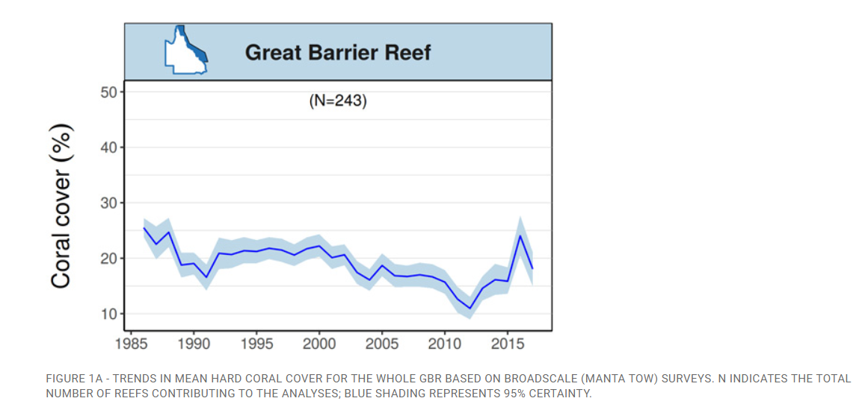
Figure 1: coral cover for the GBR from then 2016/17 AIMS report on the GBR. This was the last year that AIMS reported the coral cover for the entire GBR. After this they only reported coral cover for individual reefs and various regions within the GBR.

At issue is the graph of coral cover which has been calculated by Ridd (Figure 2). Figure 2 is the same as Figure 1, but extended to 2023 using AIMS data. A major point is that the coral cover statistics for 2022 are shown at record levels. Is this a reasonable conclusion?
The other important point of this data is that coral cover is now far higher than in 2012 – more than double. For this to be untrue, the uncertainty margin would have to be +/-0.1, three times bigger than is reported in the AIMS graphs.

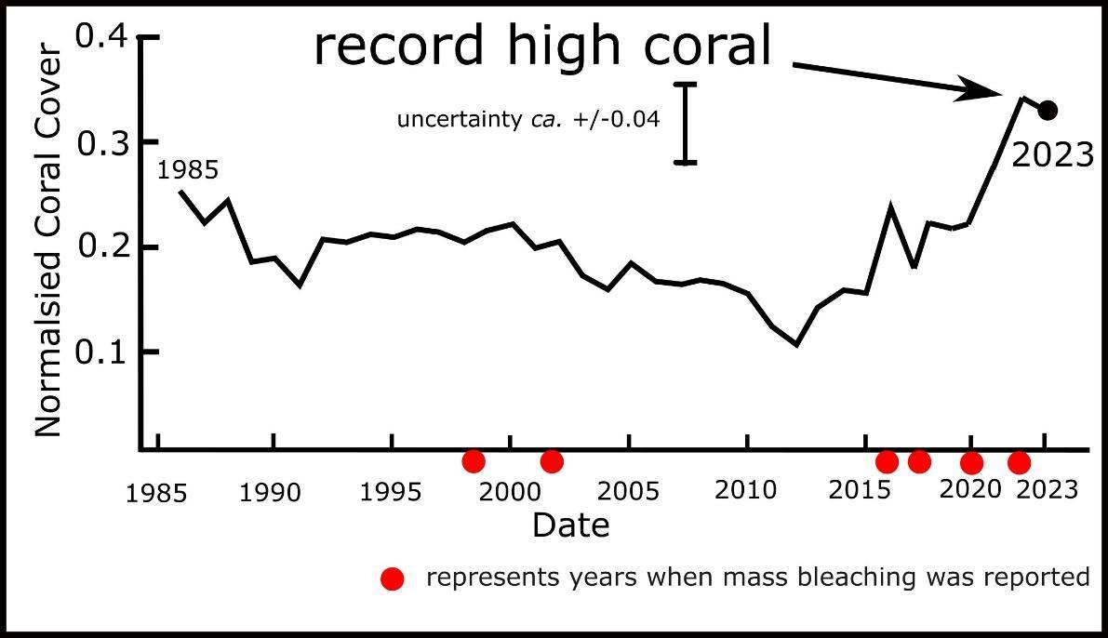
Figure 2: Coral cover for the GBR using exactly what AIMS present up to 2016/7 and then using AIMS data for the 11 GBR sectors to calculate the values thereafter.
Random and systematic uncertainty will now be considered. It will be shown that the random errors are a lot less than 0.03, and although systematic errors are harder to quantify, the total error is probably around +/-0.4.
Random Errors, and error introduced by categorising raw data.
When AIMS collect data for each 100m (roughly) segment of a reef’s perimeter, they ascribe it to one of the following categories of coral cover: 0-0.1, 0.1-0.3, 0.3-0.5, 0.5-0.75, 0.75-1, implying a relative error of roughly 100%, 50%, 25%, 20% and 15% respectively (taking the relative uncertainty to be half the interval divided by the mid-point of the interval). These are extremely large values, but the uncertainty in the mean coral cover for the entire GBR, for which there are roughly 5000 segments measured each year (roughly 100 reefs with around 50 segments per reef), is far lower. The contribution of these broad category classes to the uncertainty of the final GBR average coral cover can be gauged in the following.
It will be assumed for convenience that the ‘average’ uncertainty of individual measurements to be 50% (i.e. most of the values are in the 0.1-0.3 class).
The Standard Error of the mean (SEM) is given by the formula
SEM = σ / √n
σ is the standard deviation of the measurements.
n is the number of measurements (roughly 5000)
Given that each measurement has an uncertainty of 50%, the standard deviation (σ) is roughly 50% of the average value (x).
SEM = (0.5x) / √5000
SEM ≈ 0.007x
So, the uncertainty due to the ‘width’ of the categories is a little less than 1% relative error. For a typical coral cover of 0.25, 1% error corresponds to an absolute uncertainty of +/-0.0025 compared to the uncertainty that AIMS reports of +/-0.03. It can thus be seen that the uncertainty due to the coarse categorisation of the raw data is not a major source of error for the GBR average due to the very large number of samples that contribute to the average (roughly 5000).
Note, for an individual reef with only 50 segments, the SEM is 7% as the error goes up with the square root of the sample size. For a typical coral cover of 0.25, this would be equivalent to an uncertainty of +/- 0.02. For example, AIMS data for Chicken Reef (figure 3), which has roughly 50 segments, has an error bar of roughly +/-0.04 (in normalised coral cover units). This is higher than calculated here and AIMS doubtless ascribe extra error to other sources.

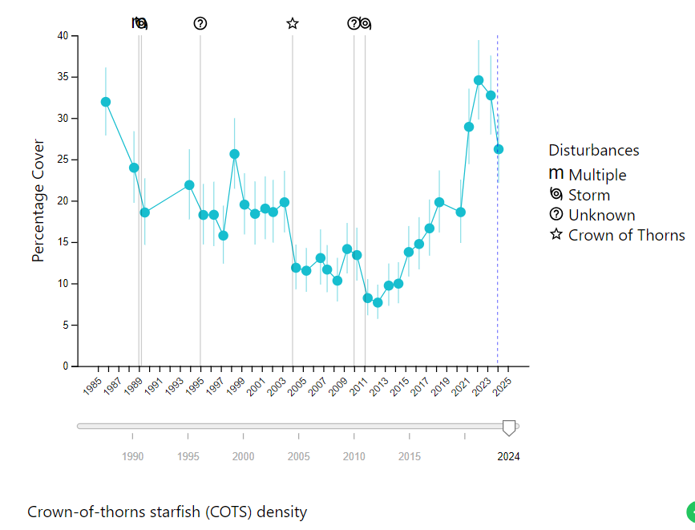
Figure 3: Screen shot of AIMS data for Chicken Reef showing uncertainty estimate of approximately +/- 0.04 (+/-4% coral cover)

Systematic Errors
Systematic errors are most likely to be the biggest cause of uncertainty, and these systematic errors are likely to occur in a quasi-random manner. The most likely cause of systematic errors is that the divers who observe the coral cover may not be consistent from one year to another, and different divers will produce different values as these are subjective measurements. It would be useful if AIMS could publish tests that may have been done to determine what these systematic differences between observers are.
In measurements of almost any parameter, from the emission of microwaves from the cosmic microwave background to noise in electronic amplifier circuits, some idea of the noise in a signal/measurement can be gained by a careful consideration of the fluctuations in the data. In this case it is possible to look at fluctuations in the data to gauge an upper estimate of the total uncertainty using knowledge of the growth rates of corals and also periods after major disturbances, such as after Cyclones Yasi and Hamish. Reefs can lose huge amounts of coral overnight, but recovery is slow as it is limited by the growth rate of corals. Recover periods are very useful in gauging uncertainty in the data. In addition, the year-to-year variability can also be used to give an upper estimate of uncertainty.

High frequency (yearly) fluctuations.
Consider a time series which consists of the sum a ‘real’ signal, which has random but real fluctuations, and a ‘noise’ signal caused by observer error. The fluctuations of the sum of these two signals will be greater than either the fluctuations in real signal or the noise. Thus, by choosing a period in a time series which contains only high frequency fluctuations, the fluctuations in the time series give an upper estimate of the noise – i.e if one assumes the real random fluctuations are zero, then all the random fluctuations are thus ascribed to ‘noise’ in the data collection. It is important to note that this gives an upper estimate of the noise/ uncertainty.
An example of how this can be applied to estimate the noise in the data is considering data from the northern region of the GBR (figure 4) which remained relatively constant from 1986 to 2013, with values fluctuating from maximums to minimums by about 0.08 from one year to the next. Even if there was no actual variation in coral cover in this region between 1986 and 2013, and all the fluctuations were due to systemic ‘noise’ owing to the observers, the maximum uncertainty value of those systemic changes will be about +/- 0.04. In reality, there would have been real fluctuations in coral cover during this period and thus some of the fluctuations in the time series are not due to sample error.

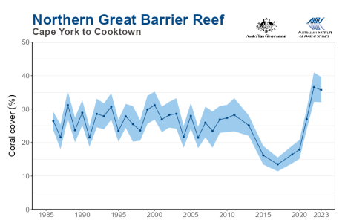
Figure 4: Screenshot of AIMS coral data for the Northern GBR

Data of recovery from extremely low coral cover.
Data of a reef with the smallest absolute uncertainty occurs when there is a minimum of coral. This is because it is very easy for observers to judge that there is almost no coral. Ironically it is also the condition with the highest relative uncertainty. For example, if a true value of normalised coral cover for a reef was 0.05, (as in 0-0.1 category), the implied absolute value of uncertainty is 0.05, which is a roughly 100% relative error.
From knowledge of the typical recovery time of corals to re-establish themselves, it must be expected that it will take more than 5 years before coral cover values will reach the average value for most reefs of about 0.25, or more. A doubling of coral cover in a year or two seems to be the highest increase rate that occurs. A sign of noisy data would be if the coral suddenly jumped up from very low values to high values in one year. For example, it would be suspicious if normalised coral cover for a reef jumped from 0.05 to 0.3 in one year. Coral can’t grow that fast and it could only be due observational errors. A perusal of the data indicates that this does not happen. In the following we will consider the recovery of a few reefs from very low values after cyclones and demonstrate that the data is consistent with knowledge of coral recovery, thus indicating relatively low uncertainty.
Lady Musgrave Island (figure 5) recovered from Cyclone Hamish (2009) with coral cover of about 0.15 in 2009 to 0.6 in 2022. The ‘noise’ in the recovery is quite low with an almost monotonic rise during this period. The small drop of about 0.06 between 2019 and 2020 may be a real fall in the coral cover, but even if it is entirely due to observer error, it is a small error (about 0.08 and thus covered by the +/-0.4 margin).
At the risk of labouring the point, it may be useful to contemplate what figure 5 would look like if the observational error was much larger, for example if the coral cover suddenly jumped from 0.15 in 2010 to 0.4 in 2011, and then back to 0.2 in 2012. As we cannot know beforehand the relative contributions of the real signal and the observational noise, one would have to conclude that all of those fluctuations might have been observer error. To be conservative one might ascribe all of that fluctuation to observer error i.e. a fluctuation of up to 0.25 under those circumstances. However, such large fluctuations (from very low values) are not seen in the data, giving some confidence that the uncertainty is far lower.
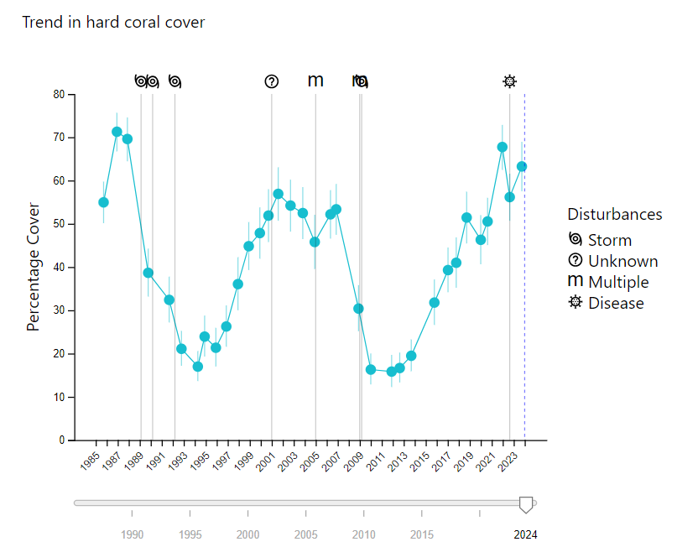
Figure 5 Musgrave Island coral cover

Another way to gauge the uncertainty is to look at how reefs close to each other respond to a cyclone. It is reasonable to expect that coral cover will fall and then recover synchronously for the two reefs. For example, compare the data for Lady Musgrave Island (figure 5) with One Tree Island (figure 6). Both show a collapse around 2010, and a roughly monotonic recovery. If the data was entirely noisy, and incapable of measuring any real change in coral cover, it would be improbable to have two such highly coherent time series, unless we are to conclude that the observers are incapable of distinguishing coral cover of 0.15 coral cover from 0.60, and that the observer error increased consistently and almost monotonically from 2010 to 2022.

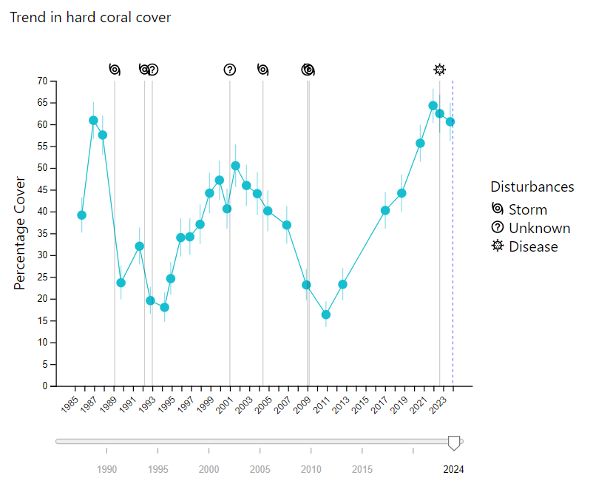
Figure 6 One Tree Island coral cover
On a larger scale, consider the recovery of the Pompey sector (figure 7) and Capricorn Bunker (figure 8) sector after Cyclone Hamish in 2009. The high frequency (yearly) fluctuations in the data after 2009 is generally much less than 0.08 from peak to trough, with a very consistent rise in both cases. This would indicate an uncertainty of no more than +/-0.04.
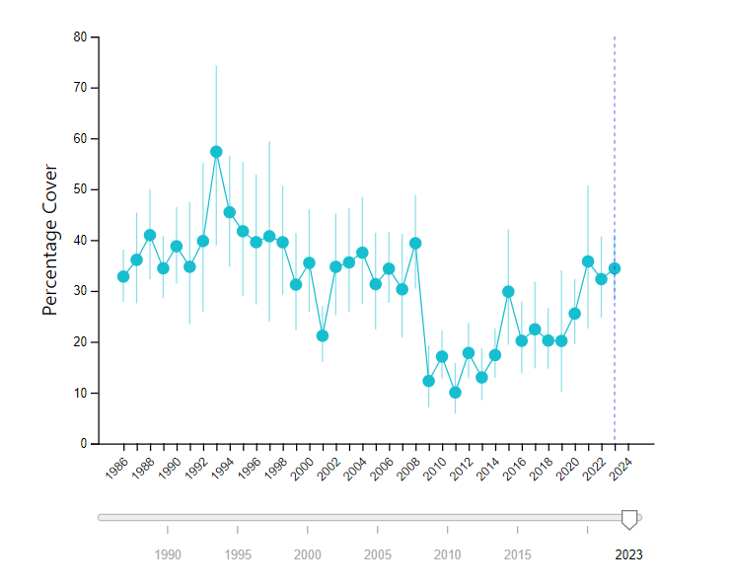
Figure 7 Pompey Sector (roughly 10% of the GBR)

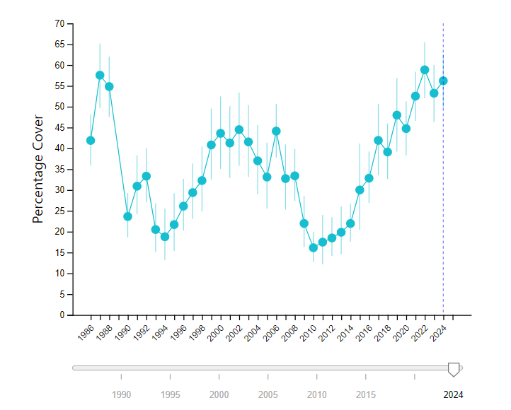
Figure 8 Capricorn Bunker Sector coral cover (roughly10% of GBR)

In order to demonstrate that the example used above are not special, the recovery of reefs in a completely different region, after different cyclones will now be considered. viz. Cyclones Larry and Yasi.
The recovery from Cyclones Larry (2006) and Yasi (2011) also show a steep decline in coral followed by an almost monotonic recovery. The short-term variability of the data is low.
The data from these reefs is consistent with a major loss of coral followed by a steady recovery. It is hard to imagine how a systematic error caused this shape of graph, and also caused the similar shape of graph for One Tree Island reef and Lady Musgrave Reefs at different dates and following different cyclones. This is strong evidence that the data is useful for considering major changes in coral cover after cyclones.

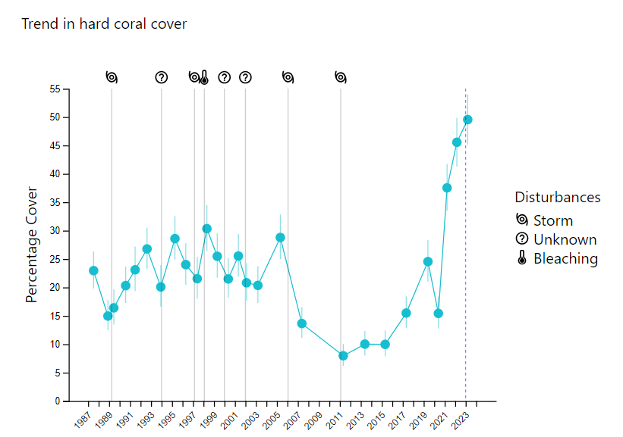
Figure 9 Myrmidon Reef

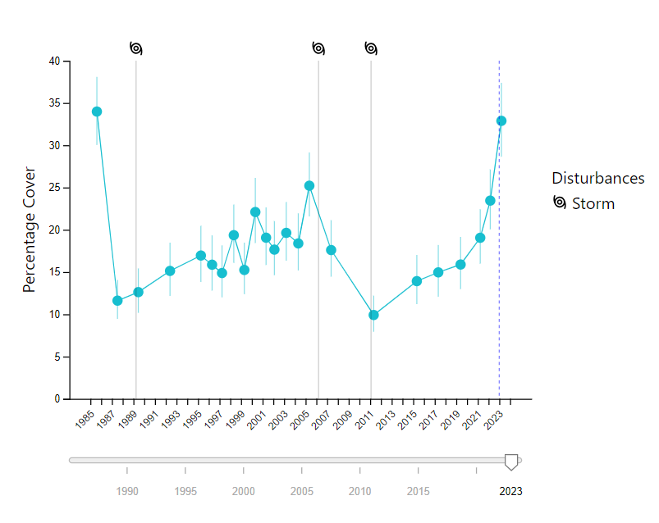
Figure 10 Dip Reef coral cover

General
One of the notable features of the high coral cover statistics of 2022/23 is that it can be seen to be at the end of a 5-10 year period of steadily increasing coral cover over most regions/sectors of the reef (figure 11). It is not a single ‘spike’ in the data that would indicate noisy data or some systemic problem for a short period. The northern region increased steadily from 0.13 to 0.36 the central region increased steadily from 0.12 to 0.35, and the southern region increased steadily 0.12 to 0.35.

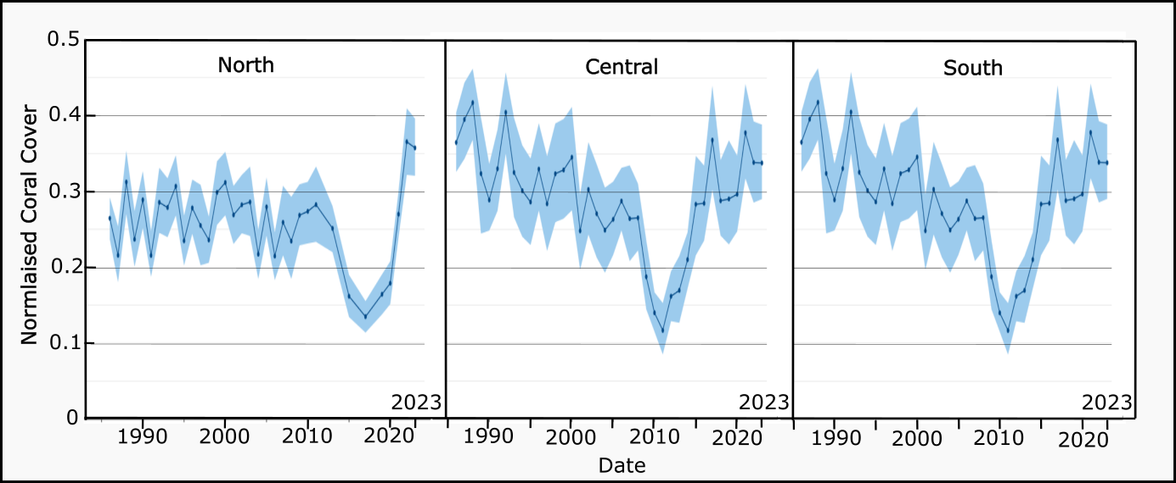
Figure 11: Coral cover for the Great Barrier Reef major regions

Analysis of the recovery of reefs after cyclones leaves no doubt that the monitoring can detect major changes in coral cover, such as the doubling of coral cover for the GBR between 2012 and 2022.
An uncertainty of +/-0.04, which has been used in Figure 2, is slightly higher than claimed by AIMS, but this means that any inferences about difference between years are more conservative than made using the AIMS uncertainty bounds. Uncertainty caused by the broad categories of the initial raw data is about +/- 0.0025, i.e. not a major cause of uncertainty.

AIMS reports coral cover as a percentage of the seabed. The author usually reports coral cover as a normalised figure with 0 representing 0% cover and 1 representing full coral cover. These will sometimes be used interchangeably in this document as I will be using screenshots of AIMS data. An uncertainty of 0.03 represents an uncertainty of 3% of the seabed.
See details at https://platogbr.com/308-2/
Note here that these percentages are the relative errors and not coral cover statistics, which AIMS reports as percentages. To avoid confusion, when reporting relative changes as percentages and coral cover as percentages, Ridd generally uses normalised values of coral cover.
For example for the category 0.1-0.3, the midpoint is 0.2, and half the range is 0.1, giving an uncertainty of 0.1/0.2= 50%.
Here we are considering the total uncertainty from all sources, random or systematic.
In the mathematical sense, steadily increasing with no reversals

